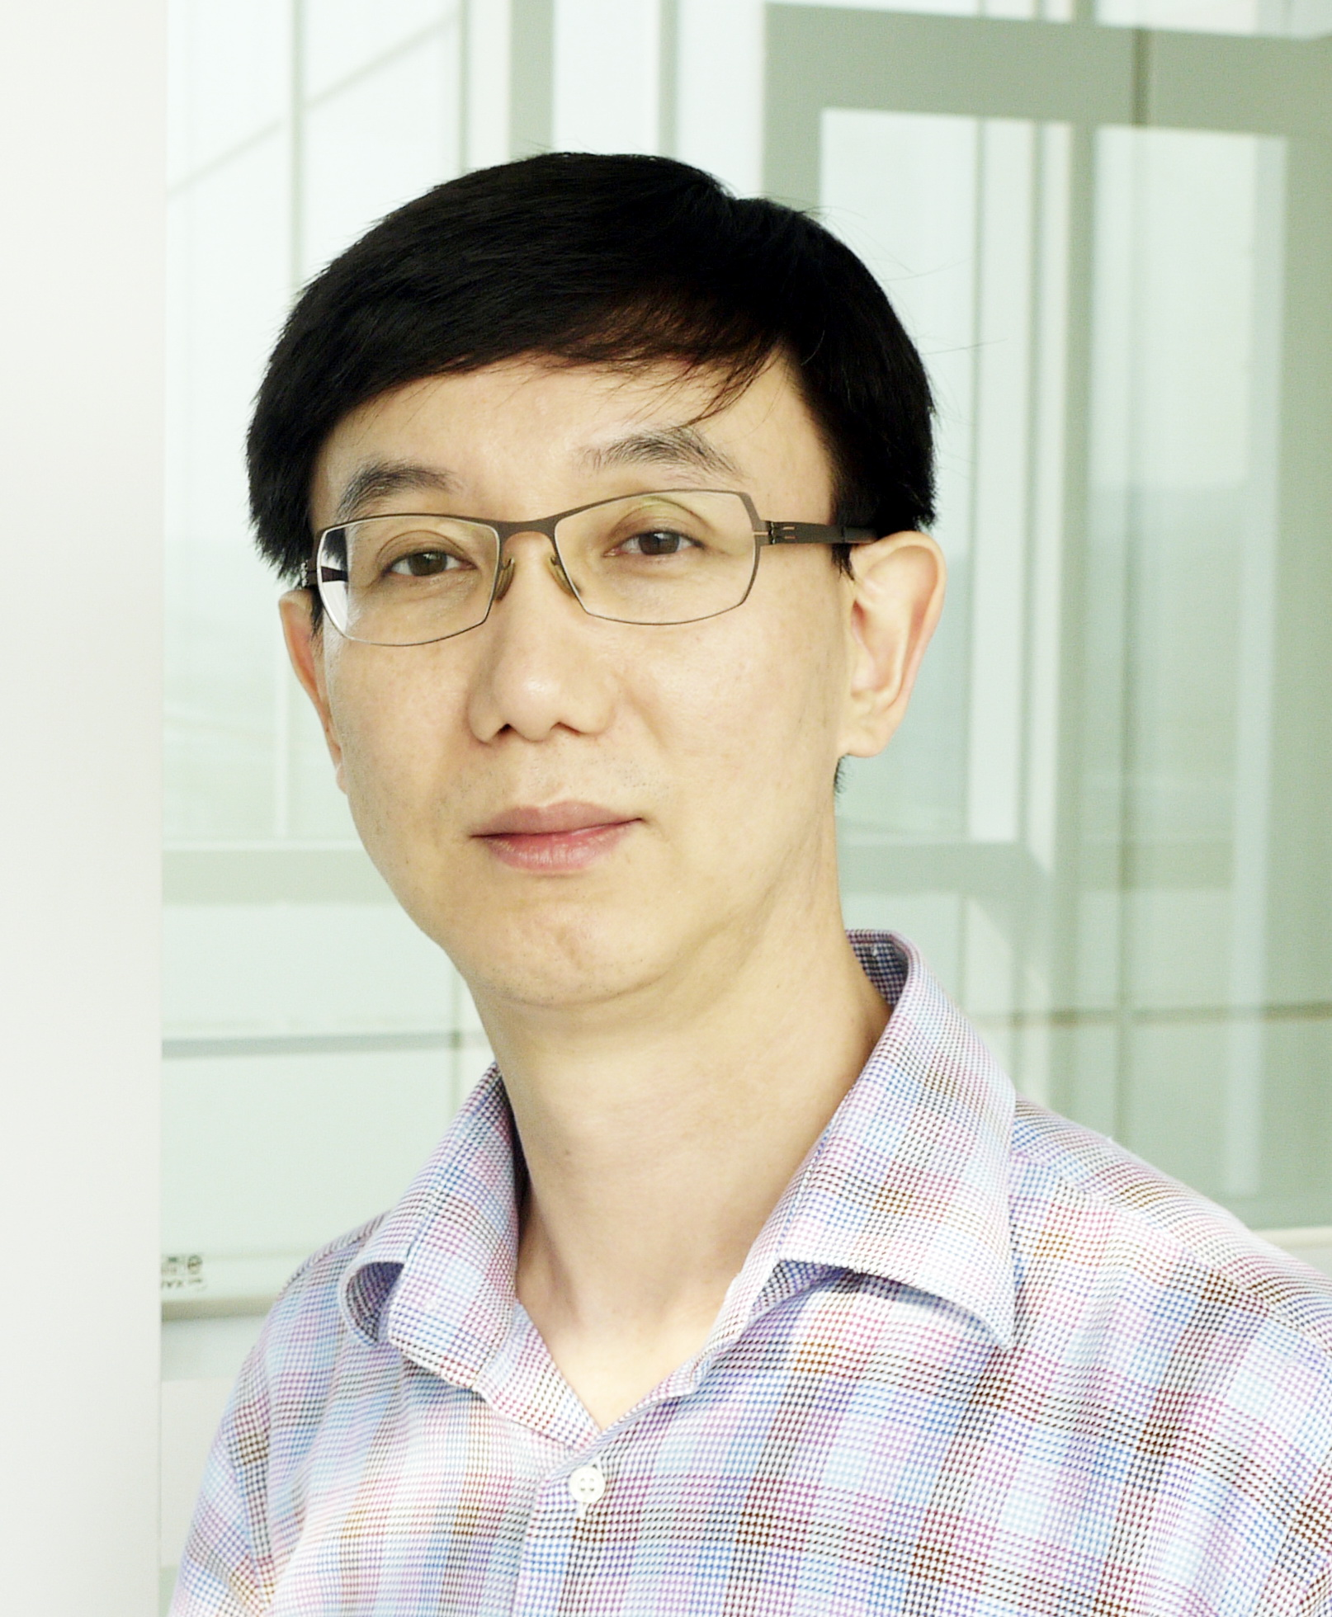

Gyu-Seog Choi, M.D., Ph.D.
Professor, Head of Colorectal cancer Center, Director of MIS & Robotic Surgery Training and Research Center, Kyungpook National University Medical Center, School of Medicine, Daegu, Korea

He graduated school of medicine, Kyungpook national university and completed surgical residency at Kyungpook national university hospital in Daegu, Korea. He received degree of Ph.D. at the same university and he pursued research fellowship for cancer genetics at Cancer research UK, Oxford, UK. After his return to Korea, prof. Choi organized MIS training and research center at Kyungpook national university hospital. Dr. Gyu-Seog Choi is one of the early pioneers of robotic colorectal surgery and developed one of the first dVLAR and dV Right Colectomy procedure technique materials with Intuitive Surgical. Since 2008, he completed approximately 1000 robotic, 7000 laparoscopic colorectal cases and has many publications and pending abstracts on robotic colorectal surgery. He actively teaches robotic surgery to his peers in S. Korea, US and around the world, and is an active/founding member of several robotic associations and societies. As an active member of many domestic and international scientific societies, he contributed over 200 papers in surgical and oncologic field of science. Many outstanding achievements have led him to win the prizes including Karl-Storz award from EAES,Gerald Marks Rectal Cancer Award from SAGES. At present he is a professor in Kyungpook national university Chilgok hospital. His main interests are MIS and robotic surgery for colorectal cancer and cancer immunogenetics.

